**9-26-23 notes**

Reading and Writing in Python

Goals:

By the end of this lesson, you will be able to:

* Read/write data from/to CSV files with Python.
* Zip two lists together.
* Create and execute Python functions.

CSV stands for Comma Seperated Values

Casting is the act of changing the variable type

Example- integer to string

All the solutions here are .py files.

**Review from yesterday:**

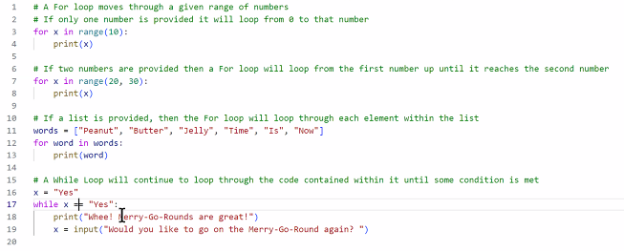

**7:20pm -Kid in a candy store activity:**

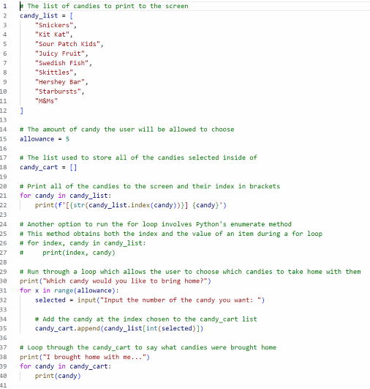

Line 18- make an empty list

Line 35- append new items to the empty list

**Pdeudocode for House of Pies activity:**

Set Boolean True. AKA Flag. In code blow it’s line 2 Shopping = ‘y’ until the user inputs (n)o

Make cart (empty list)

Len function for length of shopping cart (line 38 in code below)

While loop (“Would you like to make another order?” at end of each iteration of loop)

For loop is a set/finite number of iterations

While loop is infinite if not stopped

* ENDLESS LOOP!!!
* These can be caught during code review

**House of pies solution:**

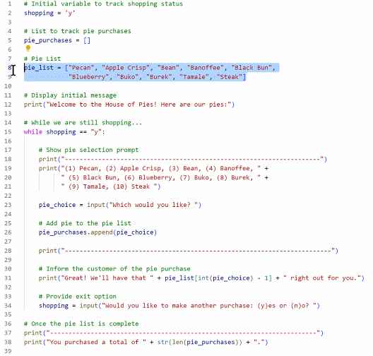

Tricky part- Lists start with unit 0, not 1

Line 31 addresses taking away 1 from the input to find the index for the pie choice so you can return the pie they said they wanted.

Up to this point, we’ve been working with data in the file that we’re changing the code in.

Here on out, we’re pulling the data from a data file.

Relative file pathing: *file = “resources/input.txt”*

* .. means to go up a level
* / means to go down/deeper a level
* ../../ goes a level up and then another level up.

Absolute file pathing: file = C:/users/Khrystyne…..

* If file is on a different drive, you need to use absolute pathing
* \\ is the start of the absolute pathing for a network drive

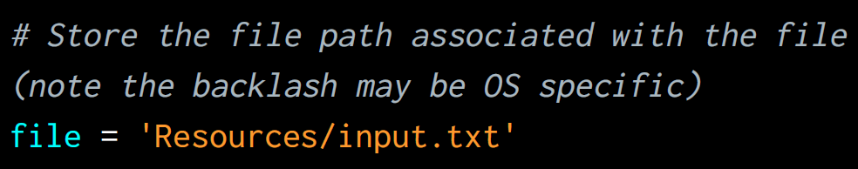

**Reading text files:**

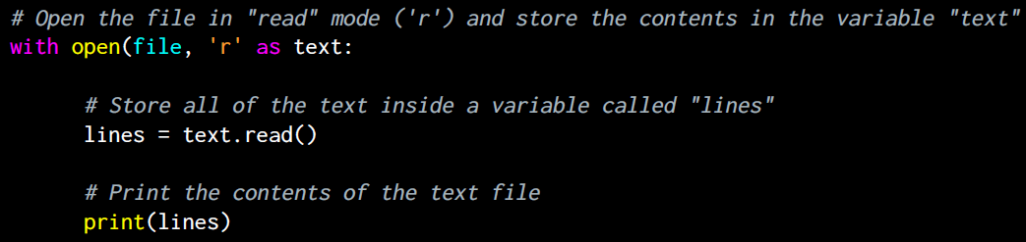

R = Read

W = Write

RW = Read and write

You can import modules that have tasks of their own

* (Like importing Marcos from one excel file to another)

Jupiter notebook saves files as .ipynb instead of .py

* Stands for Interactive PYthon NoteBook

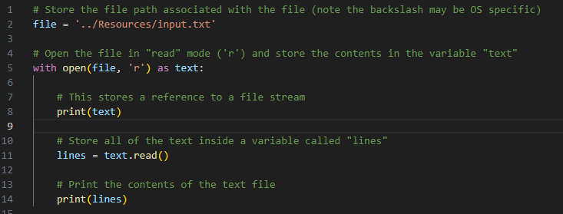

Using Jupyter to test and run code is easier than using Visual Studio Code and having to navigate to file location in PowerShell

VERY common bit of code for randoms:



**Read CSV Solution:**

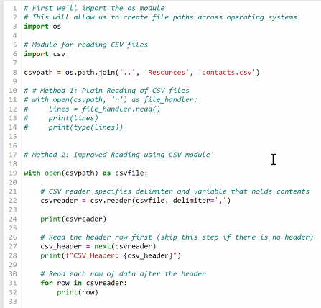

Zillow and other real estate websites expose a TON of data in CSV files

Federal census bureau has free CSV files available too

Line 22- Delimiter

Delimiter says how your data is separated out. In this case it’s with a comma

Example- data1,data2,data3,

(newline)data4,data5,data6

You can copy/paste data into excel and each item of data will go in a different cell

Line 27- Header

Defines csv_header as next

**Comic Activity Solution:**

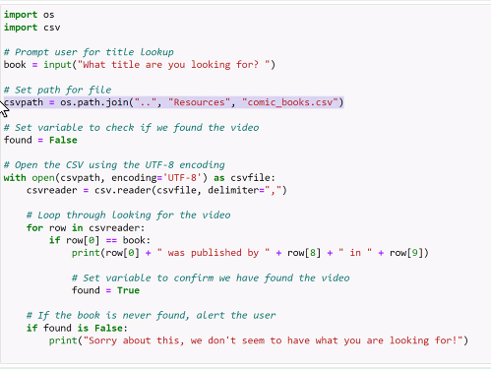

Set a flag, and it stays raised until you lower it.

In code above the flag is “found” and default setting is “False”

**Write Activity Solution:**

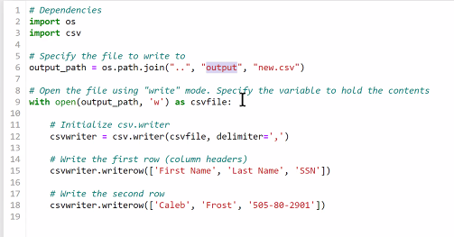

Using W is generally only used for data cleaning.

Steps: Read, copy/paste as though to write, fix the data you need to,

W will write over a file that already exists.

Put in a check to make sure there isn’t a file by the same name already

**Zipper Solution:**

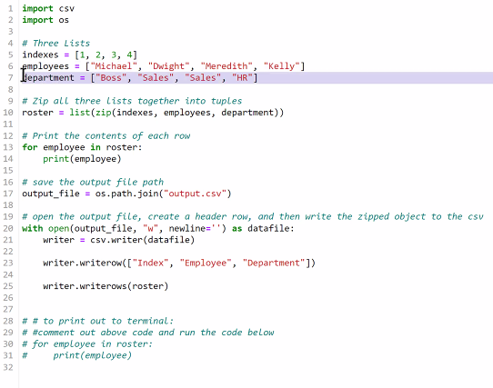

**Census Solution:**

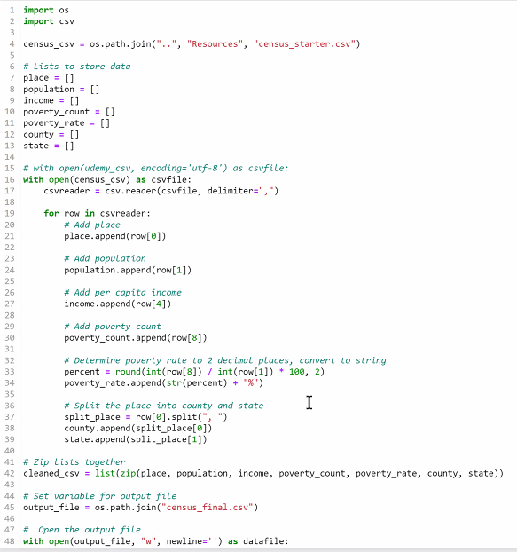

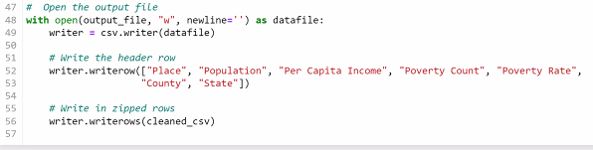

Read, Write, List

**Functions solution:**

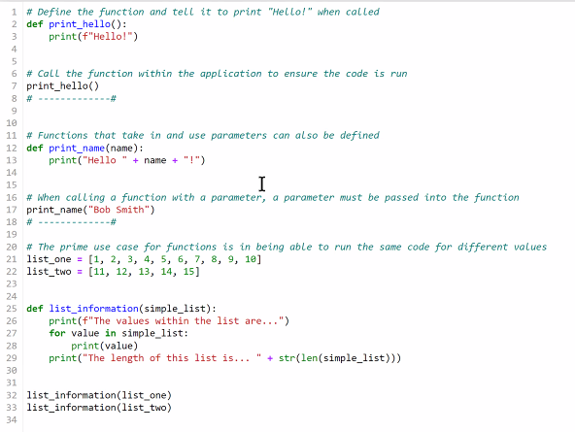

^Helper Functions.

Define the function, apply an action for the function to do.

If you write a function, you can call on it and use it infinite number of times in various files so long as the computer is attached to the file location where the helper function is saved.

The code above is a .py file (The white background and numbers on Left tell me that this is opened in Jupyter)